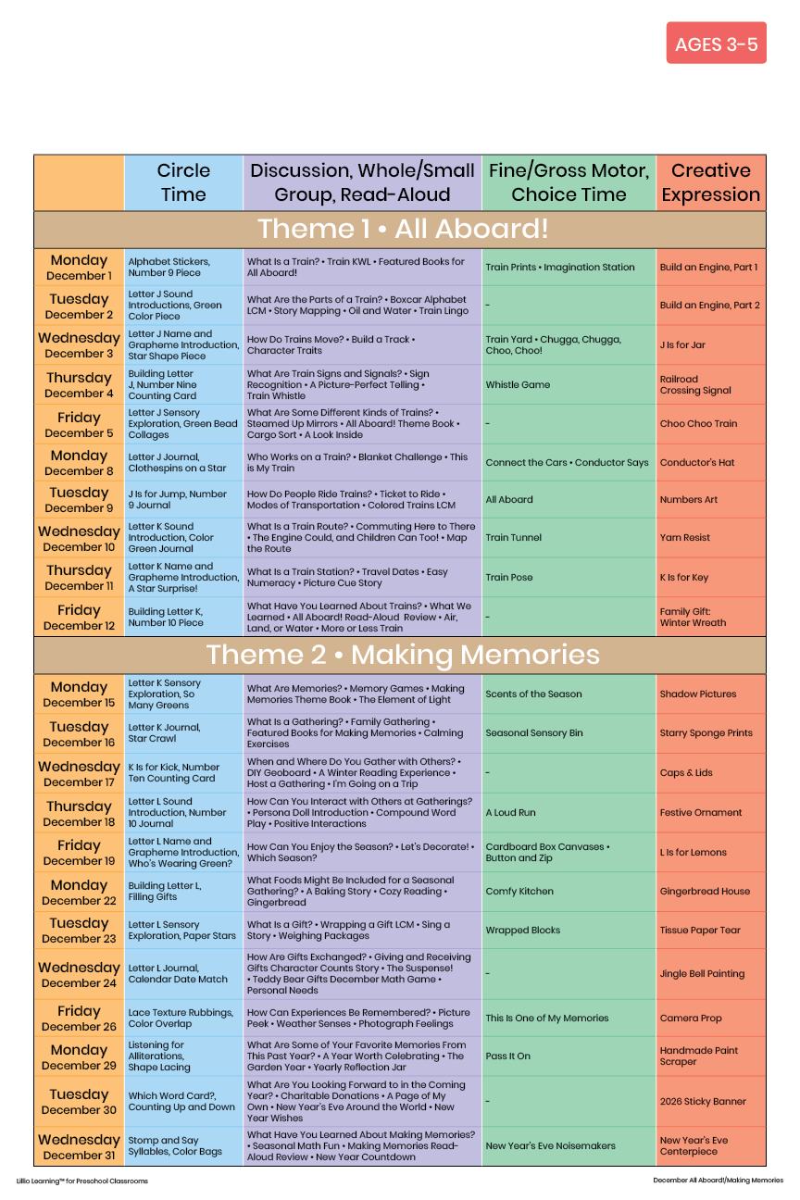

December 2025
Add Your Name/Logo Here

